Curriculum Vitae
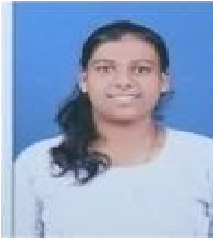
Name: Pawar Payal Shankar.

Mobile:
9028596489

E
Linkedin:
-
mail:
payalpawar692004@gmail.com
https://www.linkedin.com/in/payal-pawar-73981a2ba

CAREER

OBJECTIVE

To work in competitive atmosphere to gain good experience and achieve a respectable position in company.
TECHNICAL SKILLS
- Software languages : C, C++, Java, html, css, javascript, c#, PHP, ASP.net.
- Database: MySql, Oracle
- Operating system : windows 2007, 2008, 2010.
ACADEMIC CREDENTIALS

Examination | Institute |  | University | Year of passing | Percentage
BCA | Sadguru Maharaj Karad. | Gadage  College | Shivaji  University | 2025 | 73.85%
HSC | Sadguru Maharaj Karad. | Gadage  College | Shivaji  University | 2022 | 56.17%
SSC | Nileshwar  Maddhyamik Viddyalay,Vadoli Nileshwar. |  | Kolhapur Board | 2020 | 83.60%
ACADEMIC REPORT

- Developed A Mini project name is “Advertisement of Ladies Shopie”.
- Developed a Micro project name is “Online car servicing booking”.

EXTRA CURRICULAR ACTIVITY
- Participated in Poster presentation Subject name is AI And Machine Learning.
- Attend Python Workshop.
- Arrend R Language workshop.
- Attend AI workshop Also.
INTERPERSONAL SKILLS

- Positive attitude, Quick learner, Active team player, Ability to adapt newthings
PERSONAL INFORMATION

Name : Payal Shankar Pawar
Date of Birth : 6th Sep 2004 .
Gender : Female
Nationality : Indian
Marital Status : Single
Languages known : English, Hindi, Marathi
Permanent Address : A/p: Vadoli Nileshwar
Tal.: Karad
Dist.: Satara
PIN: 415115

I hereby declare that above mentioned information is correct up to my knowledge & I bear the response for the correctness of above mentioned particulars.

Signature,
(Miss. Pawar Payal P.)

